SVD GOVERNMENT DEGREE COLLEGE(W)
NIDADAVOLE, EAST GODAVARI DISTRICT-534301
(AFFILIATED TO ADIKAVI NANNYA UNIVERSITY, RAJAMAHENDRAVARAM)
Mail: nidadavolew.jkc@gmail.com
DEPARTMENT OF ENGLISH
REPORT ON SEMINARS/WORKSHOPS ATTENDED
WORKSHOP : TOT on SEEK & SEL
OBJECTIVE :To provide Socio-emotional learning for the teachers and students
DATE : 24-Jan-2024
VENUE : SCIM GOVT DEGREE COLLEGE(A) TANUKU
CONDUCTED BY : Collegiate Education.AP
ATTENDED BY : G.A.SONI Lec in English

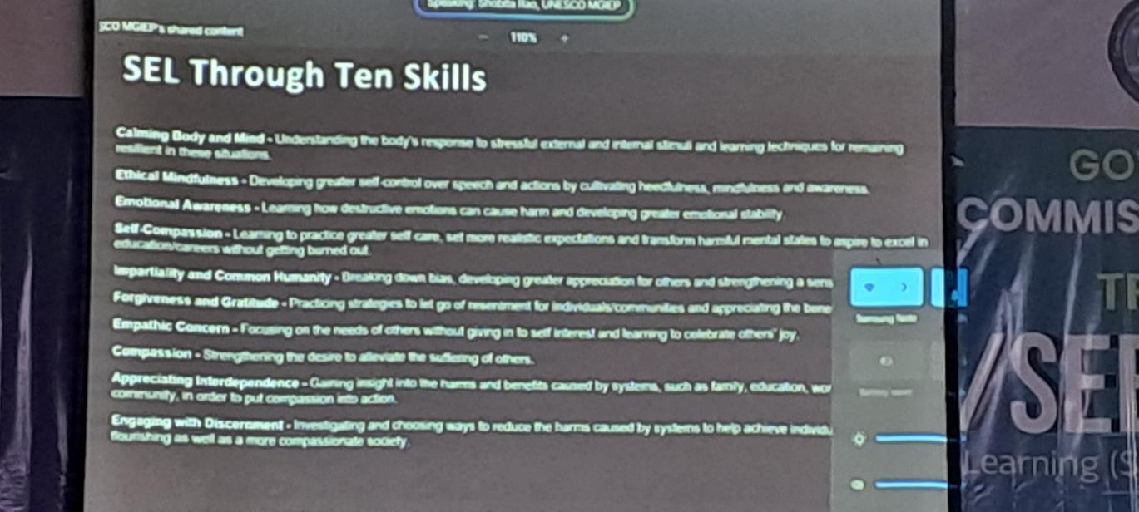

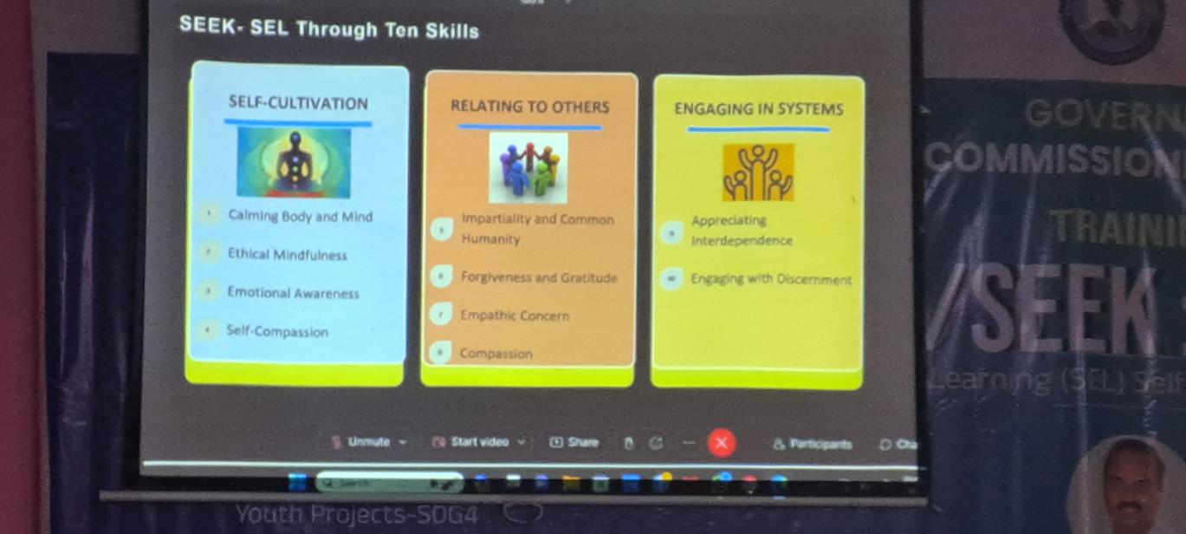
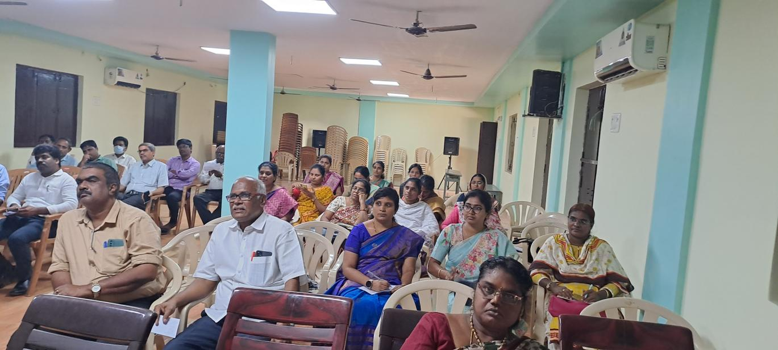
SEEL AND SEL WORKSHOP

WORKSHOP : An Interactive Workshop on English Pro-1
OBJECTIVE : Empowering English Language Teachers Through Activity and Methods
DATE : 24-April-2024
VENUE : GOVT Degree College(w), Guntur
CONDUCTED BY : Collegiate Education.AP
ATTENDED BY : Dr.M.Kambaih, G.A.SONI Lec in English

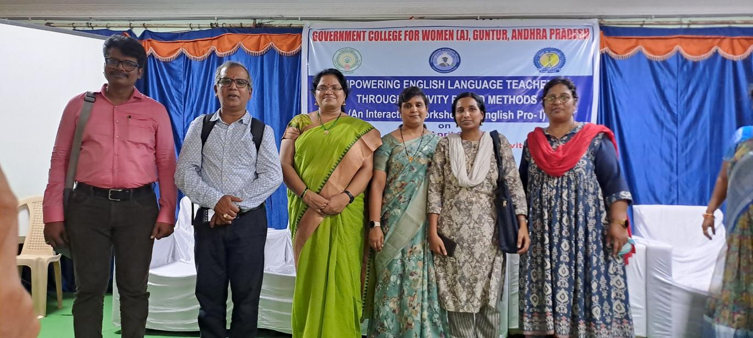

WORKSHOP : TOT On E-Content Generation
OBJECTIVE : Hands On Training on content generation
DATE : 14-Aug-2024
VENUE : SCIM GOVT DEGREE COLLEGE(A) TANUKU
CONDUCTED BY : Collegiate Education.AP
ATTENDED BY : G.A.SONI Lec in English

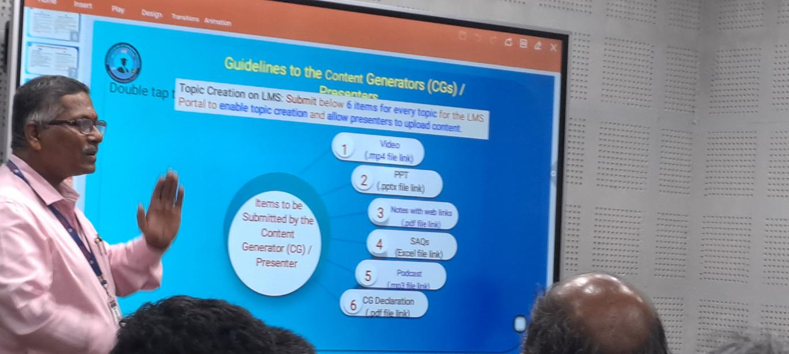
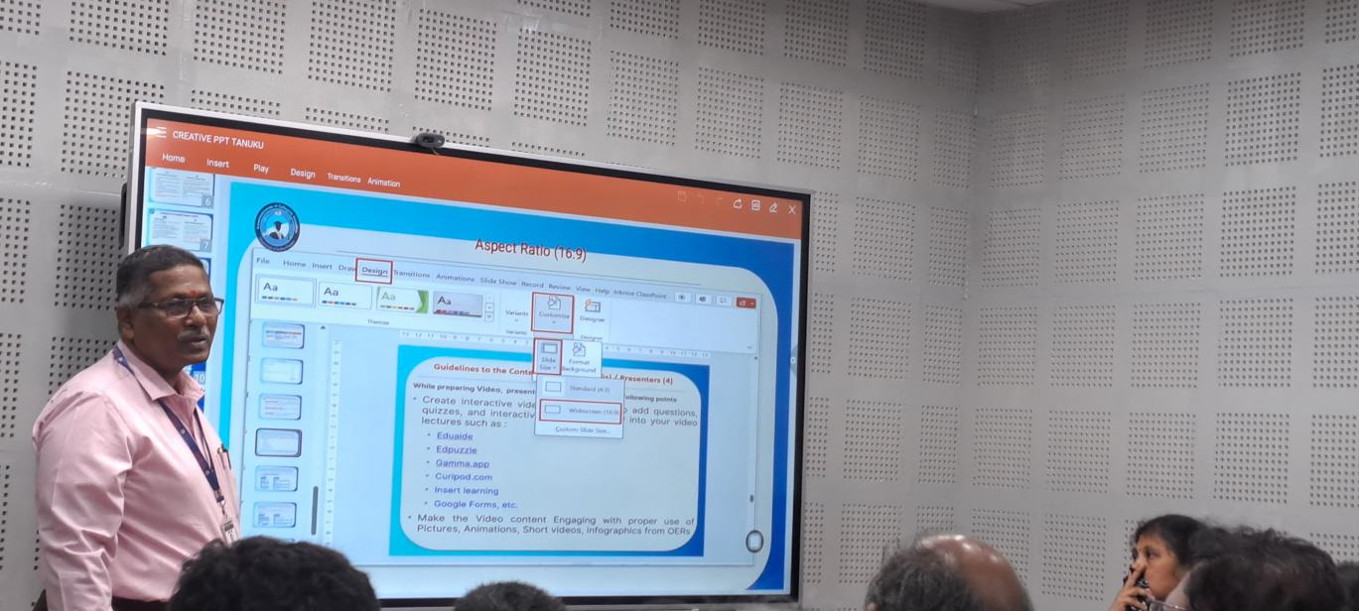
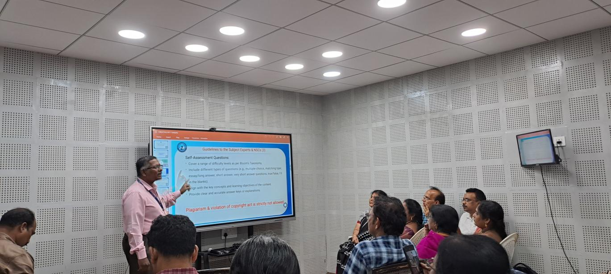
WORKSHOP ON CONTENT GENERATION

